
SOLAR LIGHT – USER INSTRUCTIONS

HOW TO CHARGE BATTERIES:
Select a location with full, direct sunlight, where it can receive at least 8 hours of sunlight each day. Shadowed locations will not allow the battery to fully charge and will reduce the hours of night time lighting. Selected location should NOT be near a night time light source such as porch lights or streetlights as this may cause the light to not come on.
NOTE: Solar lights operate independently from each other; they may be installed as far apart as needed. However accent lighting is more effective when used in groups. For best results space less than ten feet apart.

HOW TO OPERATE:
- Before first use, charge at least 6 hours.
- Turn the switch on the bottom of solar panel to:
ON: Turns light on at dusk and off in daylight.
OFF: Turns light off for shipment/storage.

IF YOUR SOLAR LIGHT DOES NOT TURN ON AT NIGHT:
- Make sure the switch is in the “ON” position.
- Battery MUST BE fully charged.
  - Make sure the solar panel is located in an area where it gets the maximum amount of sunlight every day.
  - If the weather is cloudy or overcast during the day, the battery may not recharge fully to operate properly at night. The light must receive direct sunlight every day to fully charge the battery. If the solar light does not receive enough sunlight during the day, it will be recharged during the next sunny day and then resume normal operations.
- If your solar garden light is located too close to street lights or porch lights, it will not light up on at night. Relocate your solar garden light.
- The Rechargeable Battery needs to be replaced once every 1 to 2 years.

HOW TO CHANGE BATTERIES:
- Turn the switch to the OFF position.
- Use a small Phillips screw driver to remove the four screws underneath the panel.
- Carefully remove the back cover.
- Replace the existing battery with a rechargeable battery of same size.
- Put the back cover into the position and secure it with the two back cover screws.
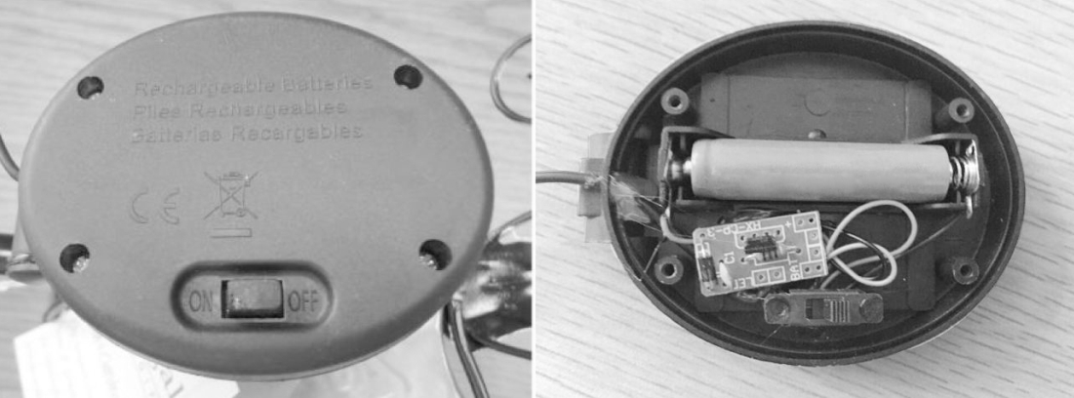
WINTER TIME TIPS:
- Keep snow and debris cleaned from the solar panel, so the battery can recharge.
- If it’s going to snow, turn the switch to the OFF position.
- After the snow melts, charge battery for 6 hours in full direct sunlight, for the battery to recharge to its full capacity. Then place the switch in the “ON” position.

TECHNICAL PARAMETERS:
Operating time: Up to 8 hours
Batteries: Rechargeable AAA 300mAh 1.2V
Light source: LED lamp

